FDIC Subcontractor Reporting System (SRS) Prime Contractor User Guide

Table of Contents
Section Pages
I. SRS Overview: 1
II. Accessing SRS: 2-3
III. Entering Subcontractor Data in SRS: 3-7
IV. Completing Subcontracting Reports in SRS: 7-11

FDIC Subcontractor Reporting System (SRS)
Prime Contractor User Guide

SRS Overview:

- Overview

The Subcontractor Reporting System (SRS) is a web-based tool that will allow Prime Contractors an on-line method for submitting Subcontracting Reporting data, as required in Clause 7.5.6-2 or 7.5.6-3 (“Subcontractor Reporting”) when subcontracting is approved under a Contract/Task Order. The SRS includes a data entry form for Prime Contractors to complete Subcontracting Reports. The SRS will allow FDIC to capture and report data on the Subcontractors used by its Prime Contractors.
The SRS is available at the following website address:
https://srs.fdic.gov/SRSWeb

- Purpose

The purpose of this User Guide is to provide Prime Contractors step-by-step procedures for accessing and submitting Subcontracting Reports to the FDIC.

- Intended Audience

The intended audience for the SRS User Guide is the person or persons within the Prime Contractor organizations that are responsible for submitting Subcontracting Reports to the FDIC.

- Additional Resources/ FDIC SRS Contact Information

Prime Contractors must contact the FDIC Contracting Officer assigned to the award to address any questions or issues with the data or how the form should be completed in SRS in order to comply with Clause 7.5.6-2 or 7.5.6-3 (“Subcontracting Reporting”), or login information such as questions locating the Prime Contractor’s FDIC Vendor ID or Contract/Task Order Number).
For technical issues such as SRS not being available when the website address is entered, or if the functionality of SRS is not working properly, Prime Contractors may contact the FDIC via email at ASBPolicy@fdic.gov.

Accessing SRS:

- Overview

The Subcontractor Reporting System (SRS) data entry form may be accessed at the following website address: https://srs.fdic.gov/SRSWeb
The website link is also specified in FDIC Contract Clause 7.5.6-2 or 7.5.6-3.
Prime Contractor s must follow the steps below to access the SRS data entry form.

Step | Action
1 | Click on the SRS website address, or paste the website URL into your internet browser: https://srs.fdic.gov/SRSWeb
2 | A Notice to Users will be displayed. Read the content and then click “Continue”.  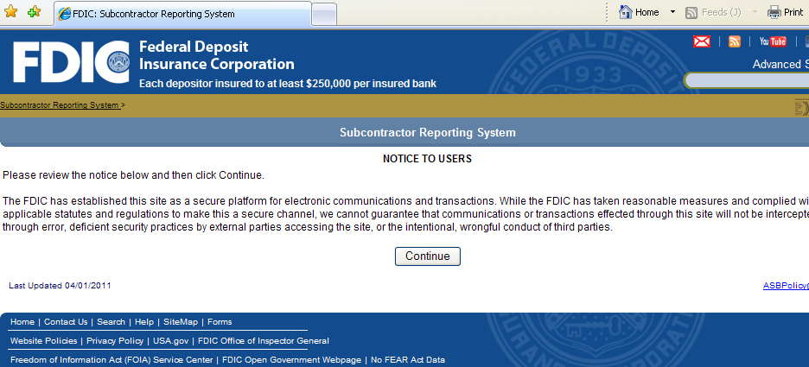
3 | Enter the 10-digit FDIC Vendor ID and a valid Contract Number assigned to the Prime Contractor by the FDIC. Then click ‘Validate’.  Please note, the numbers must be entered exactly as displayed in the contract, including all preceding zeros (for the FDIC Vendor ID) and dashes (for the Contract/Task Order Number.)  The 10-digit FDIC Vendor ID Code assigned to the Prime Contractor can be located in the following places on the Contract/Task Order or Modification Form:  - On any modifications issued after August 1, 2008, the FDIC Vendor ID Code is specified in Block 8 (the data field titled, “Code”).  - On any contract or task order awarded after August 1, 2008, the FDIC Vendor ID Code is specified in Block 17a (the data field titled, “Code”).  For assistance with locating the FDIC Vendor ID Code or Contract Number, Prime Contractors should contact the FDIC Contracting Officer assigned to the award.  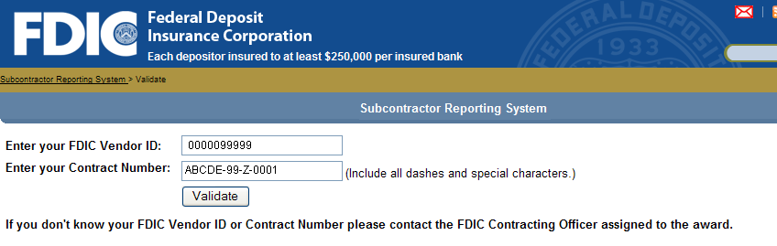

Entering Subcontractor Data in SRS:

- Overview

Once validated, the system will display all active Contracts and Task Orders associated with the Prime Contractor. However, this does not mean that subcontractor data needs to be submitted for each and every Contract/Task Order. As stated in Contract Clause 7.5.6-2 or 7.5.6-3 (“Subcontracting Reporting”), Prime Contractors are only required to submit Subcontracting Reports on Contracts/Task Orders in which the FDIC has approved subcontracting.
Note: The first time Subcontractor data is entered, a complete record must be added for each subcontractor (e.g., Subcontractor DUNS Number, Name, Address and Company Classification/Ethnicity). However, subsequent reports will only require minimal data to be entered.
Follow the steps below to add subcontractor data to SRS (which must be done before completing a Subcontracting Report in SRS).

Step | Action
1 | Select the Contract/Task Order that the Prime Contractor will be submitting Subcontractor information for.  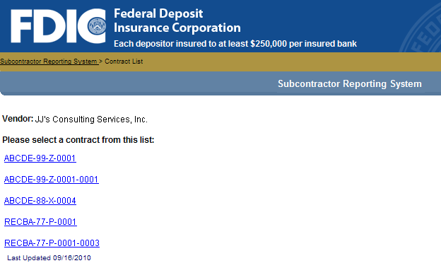
2 | The next screen that appears will display specific information regarding the Contract/Task Order, including:  - Contract/Task Order Number  - Contract/Task Order Title  - Award Value  - Award Effective Date  - Final Expiration Date  Verify that the correct Contract/Task Order has been selected then proceed to entering Subcontractor information.
3 | If Subcontractor information has previously been submitted for the Contract/Task Order, the name of the Subcontractor will be displayed on the screen.  Either select existing Subcontractor or click on “Add or Search for Subcontractor”.  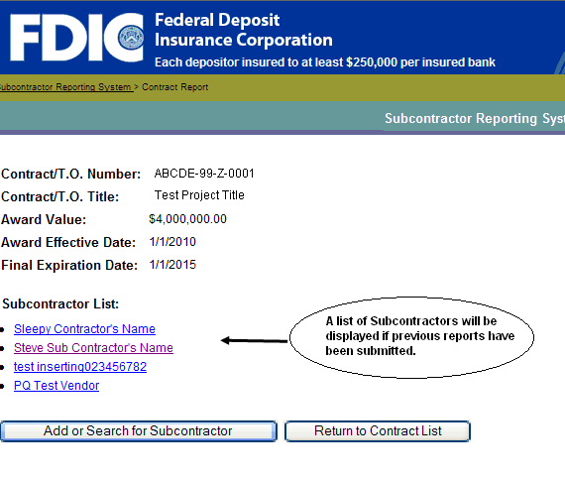
4 | When adding a new Subcontractor, enter the Subcontractor’s DUNS number followed by “Submit”. The system will check to see if that Subcontractor exists in the system or not. If it does not exist, proceed to Step 5.  If the Subcontractor does exist, the information previously submitted will be displayed and can be edited, if necessary.  Please Note: A link to the Dun & Bradstreet DUNS Number Look Up Internet site is also provided on this page if you do not know the Subcontractor’s DUNS Number.  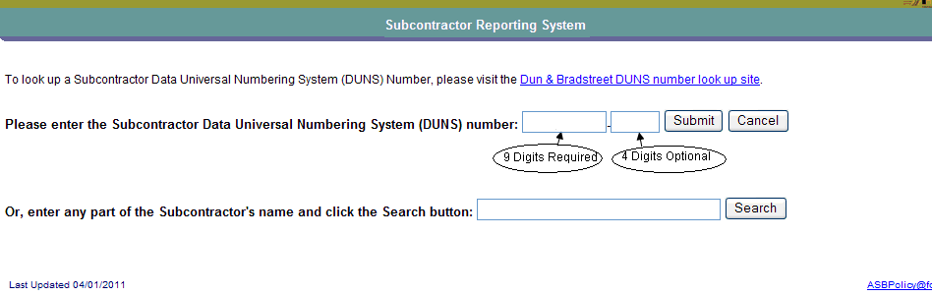
4a | Alternatively, you can search the FDIC Database to see if the Subcontractor already exists in the system by utilizing the Search feature shown above. Enter any part of the Subcontractor’s name and the system will display any company’s currently in the system that matches those criteria as shown below.  Click on the appropriate Subcontractor to add it to the Contract and then proceed to Step 5.  Please Note: This Search feature is NOT searching the Dun & Bradstreet database for valid DUNS Numbers. It is only checking the FDIC Subcontractor Reporting System to see if the Subcontractor has already been entered.  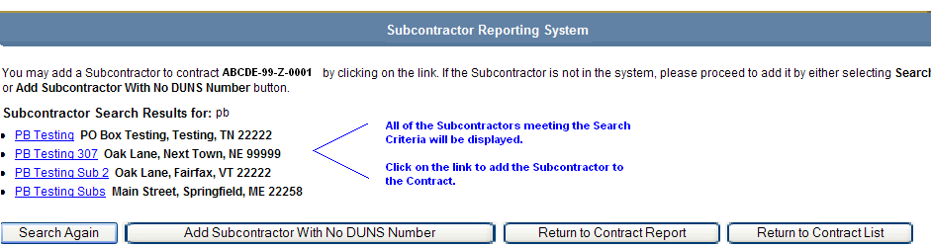
4b | If you have searched both Dun & Bradstreet and the FDIC System, and it has been determined that the Subcontractor does not have a DUNS Number, the company can be added to the FDIC system by clicking on the “Add Subcontractor With No DUNS Number” button and proceed to Step 5.  Please Note: You are NOT creating a DUNS Number using this feature nor is the entry valid in any system outside of the FDIC SRS System.
5 | Complete the Name and Address of the Subcontractor and any Company Classifications that applies followed by “Add Subcontractor”.  If you are submitting a Subcontractor with No DUNS Number, a certification button is provided on the bottom of the screen:  You must certify before the submission will be allowed.  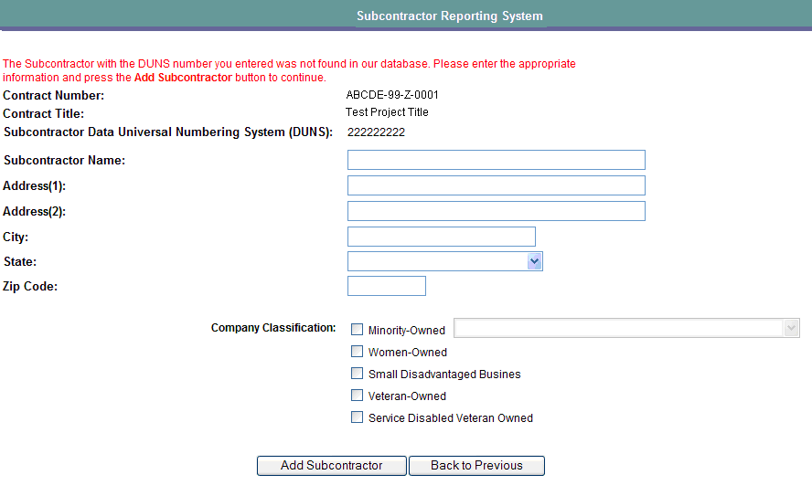  Note: If ‘Minority-Owned’ is selected as a Company Classification, one of the following Ethnicity Categories must be selected from the Drop-down list:  - Black American Owned (BAO)  - Hispanic American Owned (HAO)  - Native American Owned (NAO)  - Asian-Pacific American Owned (APAO)  - Subcontinent Asian (Asian-Indian) American Owned (SAAO)  - Other Than One of the Preceding (Other)  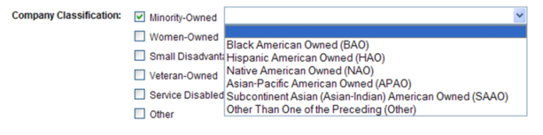  Additionally, the following message will be displayed prior to submitting the Subcontractor information: “Please confirm the information you have entered for this company is accurate. Click ‘Cancel’ to update the subcontractor data or ‘OK’ to continue.” Please note, once the data is submitted, the subcontractor name can only be changed by the FDIC. If a change to a subcontractor name is needed, notify the FDIC at ASBPolicy@fdic.gov. In your email, include your FDIC Vendor ID Code, Contract/Task Order Number, the Subcontractor’s DUNS Number, a description of the subcontractor name change needed and an explanation for the reason the subcontractor’s name must be changed in SRS (e.g., subcontractor name was spelled incorrectly, etc.).  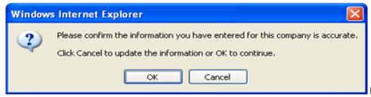
6 | Repeat Steps 3-5 until all subcontractors approved to work under the Contract/Task Order are added to SRS.

Completing Subcontracting Reports in SRS:

- Overview

Once a subcontractor is added to a Contract/Task Order, the Prime Contractor may create and submit its Subcontracting Report for a selected reporting period.
Follow the steps listed below to create and submit Subcontracting Reports in SRS.
Note: For more information regarding the data that must be entered in the particular fields, click on the What’s This link next to the field, or refer to FDIC Contract Clause 7.5.6-2 or 7.5.6-3 (“Subcontractor Reporting”).

Step | Action
1 | After subcontractor data has been entered for a specific Contract/Task Order, double click on the specific subcontractor for which the report is being created.  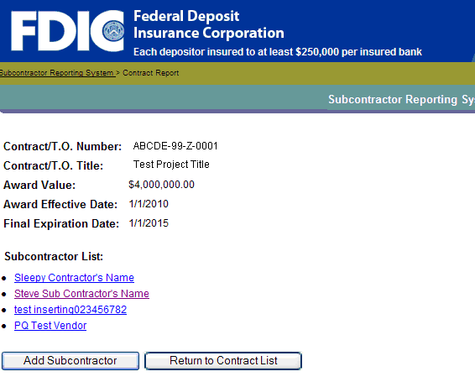
2 | From the drop down box, select a Reporting Period.
3 | Enter Submitter’s Name and Phone Number.
4 | If appropriate, update subcontractor’s address information and/or Company Classification.  Note: If the subcontractor’s name needs to be updated, contact the FDIC at ASBPolicy@fdic.gov by clicking on the e-mail link on the bottom right hand corner of the page. In your email, include the Prime Contractor’s FDIC Vendor ID Code, Contract/Task Order Number, the subcontractor’s DUNS Number, a description of the subcontractor name change needed and an explanation for the reason the subcontractor’s name must be changed in SRS (e.g., Subcontractor name was spelled incorrectly, etc.).  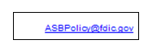  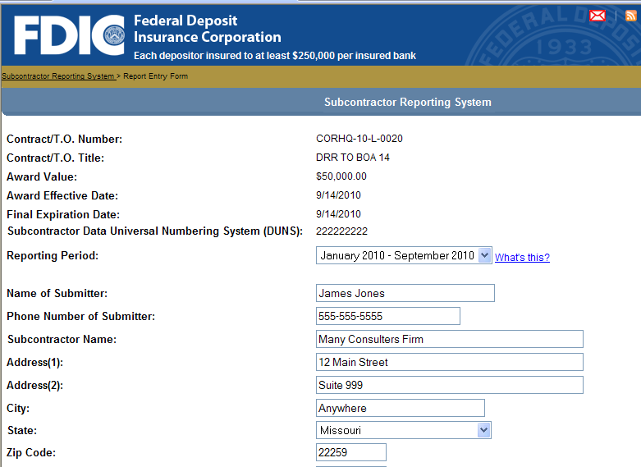
5 | Continue completing all of the date entry fields on the form followed by “Preview Report”.  Note: For more information regarding the data that must be entered in the particular fields, click on the What’s This link next to the field, or refer to FDIC Contract Clause 7.5.6-2 or 7.5.6-3 (“Subcontractor Reporting”).  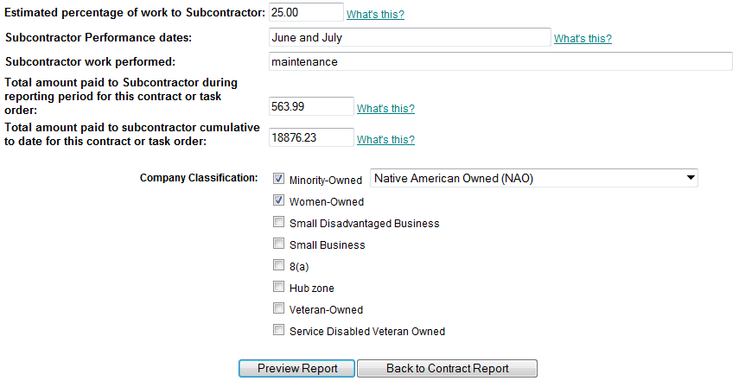
6 | A preview page will display the data that was entered. Verify the information then select the appropriate action:  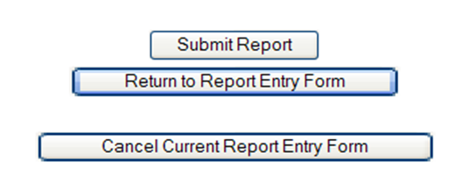
7 | Once submitted, a Confirmation Page will be displayed. Please Print or Save this information as it will not be available for viewing after leaving this page.  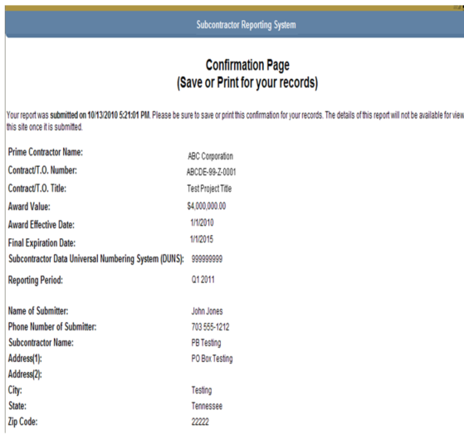  To Print of Save, use the Internet Explorer Menu options. Go to File, Save As, or File, Print:  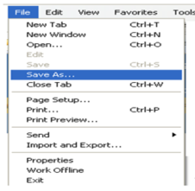
8 | Click on the “Return to Contract Report Menu” button and repeat Steps 1-7 for each Subcontractor that has been approved under the Contract/Task Order.
9 | Once completed, click on the “Return to Contract List” button.  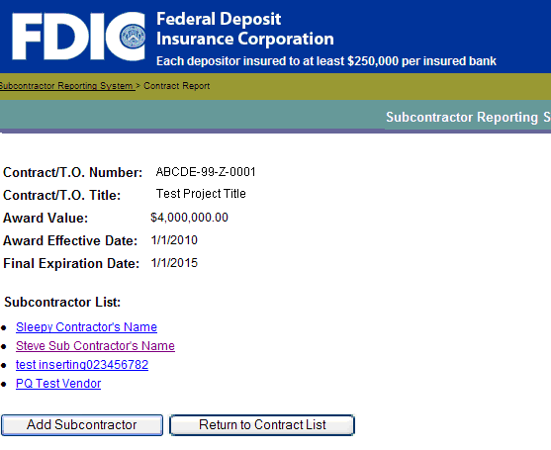
10 | Click on “End Session” button to disconnect from the form.  

End of SRS Prime Contractor User Guide

